|  |  |  |  |  |  |  |  |
| --- | --- | --- | --- | --- | --- | --- | --- |
|  | | | |  |  |  |  |
|  |  |  |  |  |  |  |  |
| **Student ID Number**  *(Do not include student name as anonymous marking is implemented)* | AMA19481452 | | | | | | |
| **Programme Title** | Computing Technologies Extended Degree EVE | | | | | | |
| **Module Title** | Web Application Security | | | | | | |
| **Module Code** *(listed on Moodle and in LTAFP)* | QAC020N256H | | | | | | |
| **Module Convenor** | Masum Billah | | | | | | |
| **Coursework Title** | Assignment 1 | | | | | | |
| **Academic Declaration:**  *Students are reminded that the electronic copy of their essay may be checked, at any point during their degree, with Turnitin or other plagiarism detection software for plagiarised material.* | | | | | | | |
| **Word Count** | 1316 | | | **Date Submitted** | | 19/07/2021 | |
|  |  | | |  | |  | |
|  | | | | | | | |

WEB APPLICATION SECURITY TESTING

Document

Contents

1. **Introduction** 2

2. **Setup a Fully Functional Web Applications** 3

a. VirtualBox setup/ configuration 3

b. XAMPP Server setup/ configuration 6

c. Mutillidae application setup 9

3. **Web Application Security Testing Setup** 11

a. NMAP scanning setup/ configuration 11

b. Wireshark sniffing setup/ configuration 18

c. SQL injection using SQLMAP setup/ configuration 22

4. **Design and Implementing a Web Security Model** 25

a. Firewall 25

b. IDS/ IPS 26

c. Antivirus 26

d. Encryption 27

5. **References** 28

# **Introduction**

Security means vulnerable to change which maintains acceptable level of risks. In network, security called processes, policies and measures adopted to prevent, detect and monitor the unauthorized access of system or computer application. Security is a process not an end state.

Currently in present era, all business being run over internet and they become more vulnerable than other because all application being operate as Web/ Cloud or Android/ IOS based technologies so their security of consumers data is most confidential and business data. According to IMPERVA reports that:-

1. 48% of all attacks campaigns targeted retail web sites while 10% financial institutions.
2. 40% of all SQL injection attack campaigns targeted retail web application.
3. 64% of all malicious HTTP traffic (Protocol violation) was targeted at retail web sites.
4. PHP applications suffer three times as many Cross Site Scripting (XSS) attacks.
5. Websites containing consumer information suffer up to 60% of the attacks.

Above mentioned all vulnerabilities of moderated in application code cause of weak security of applications, public accessibility of internet which leads to compromise of personal information of the customers and companies. As a security analyst, our job is to deliver security testing of client web sites and point out major security vulnerabilities. Following diagram explains all possible scenario of any attack:-

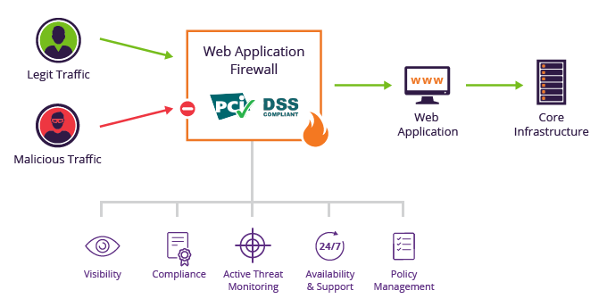

**(Web Application Security Analysis Diagram)**

# **Setup a Fully Functional Web Applications**

## VirtualBox setup/ configuration

* Visit [www.virtualbox.org](http://www.virtualbox.org) website
* Click download button on left pane of home screen as mentioned below:-

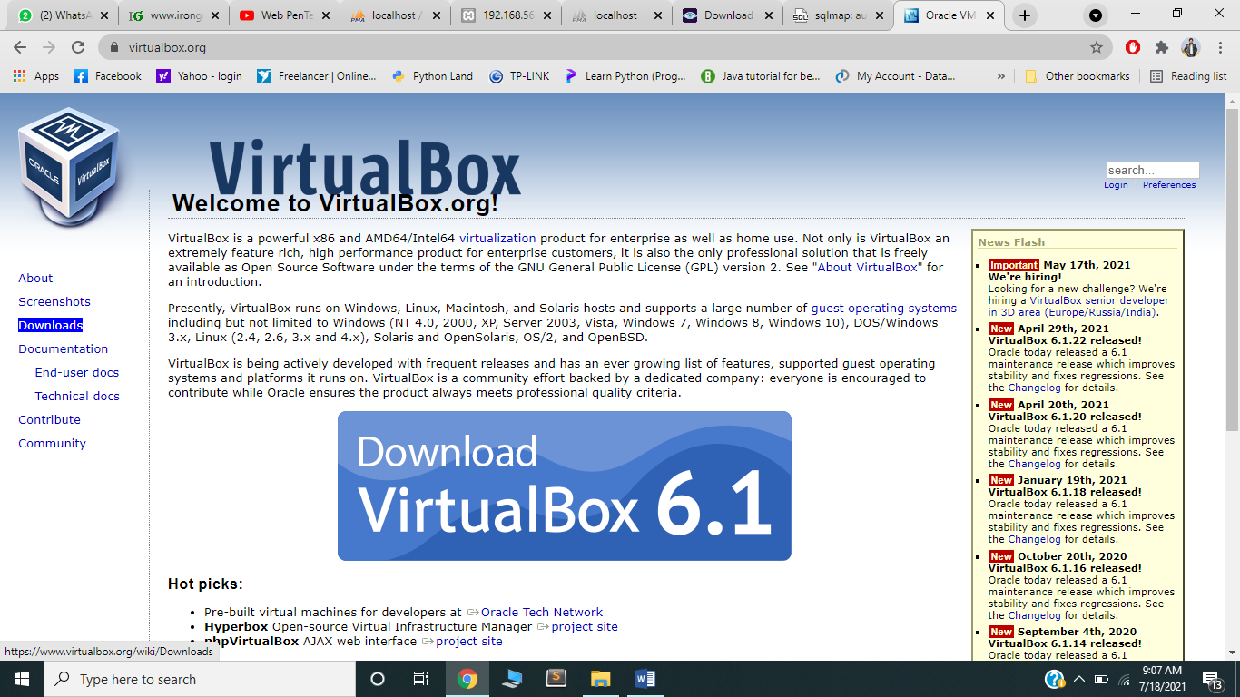

* There are different version available for different Operating Systems (OS). I downloaded for windows as mentioned below:-

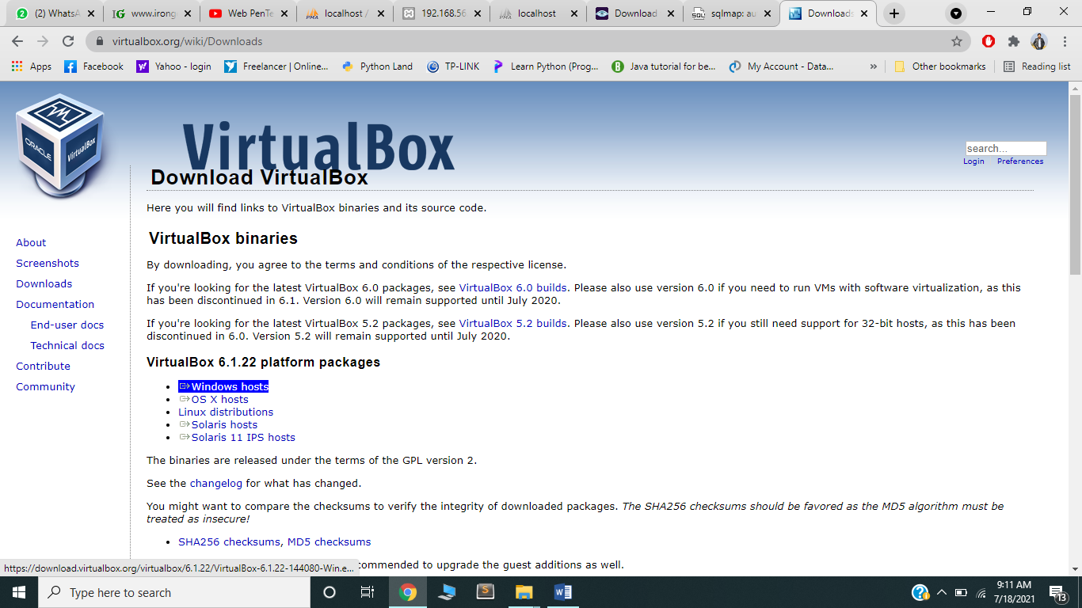

* Once the setup downloaded , launched the downloaded file to start the installation and followed steps mentioned below:-

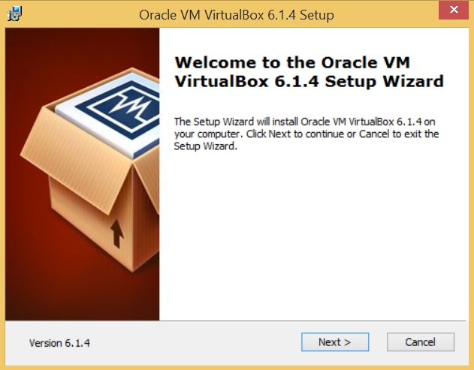

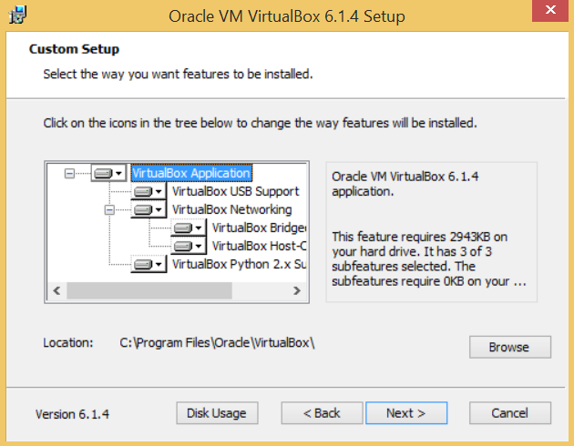

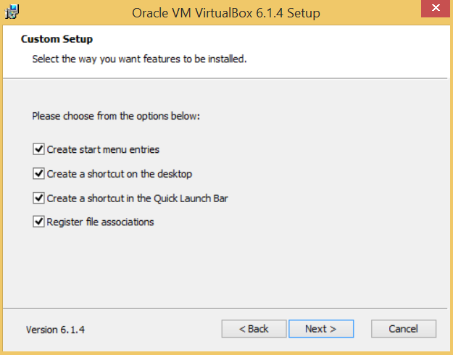

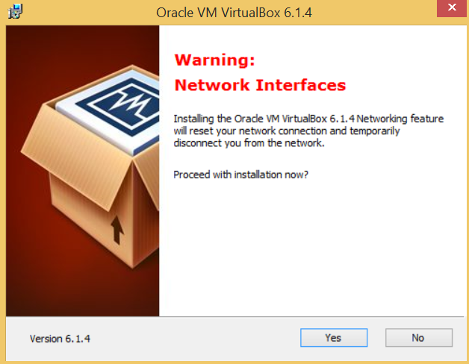

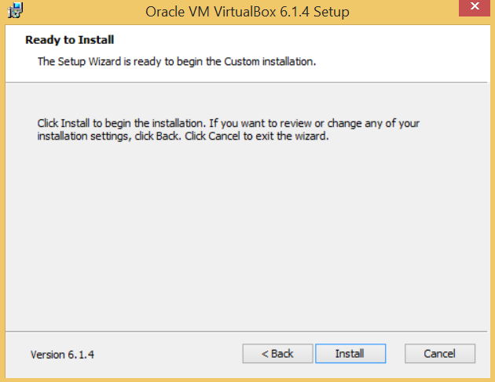

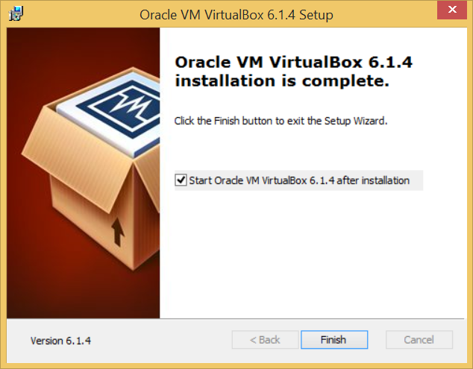

* At the end launched the virtualbox application mentioned below:-

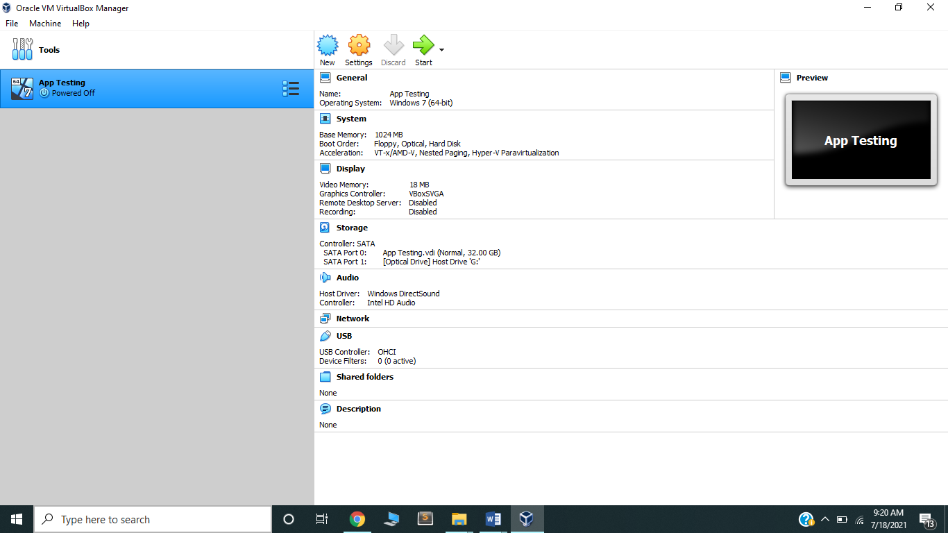

## XAMPP Server setup/ configuration

* Visit [www.apachefriends.org](http://www.apachefriends.org) website.
* Clicked the download tab from navigation bar and selected the 7.4.29 version of 64 bit.

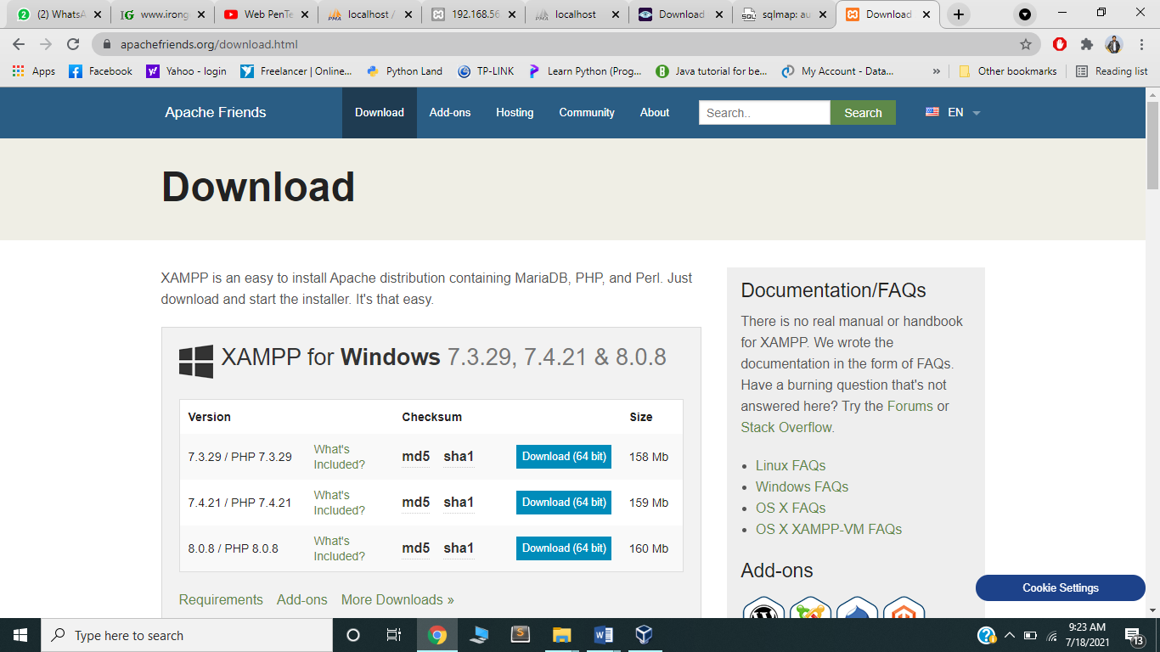

* After downloading setup, installation started according to steps mentioned below:-

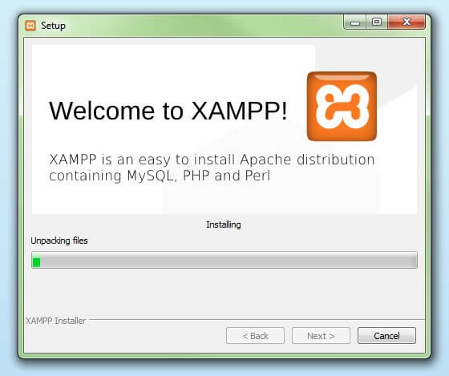



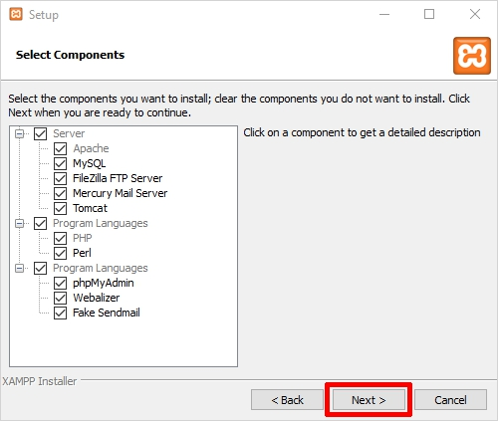

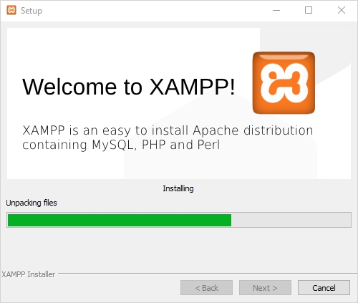

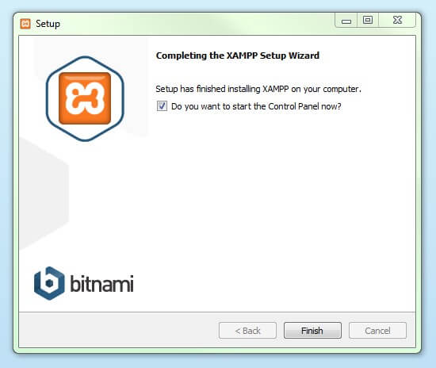

* After installation of XAMPP setup. Launched the server as mentioned below:-

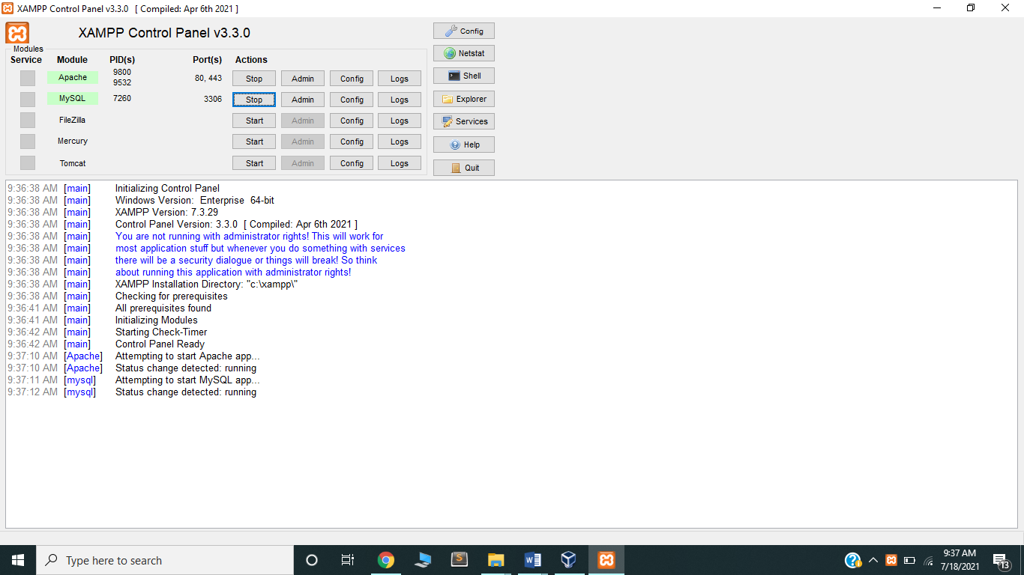

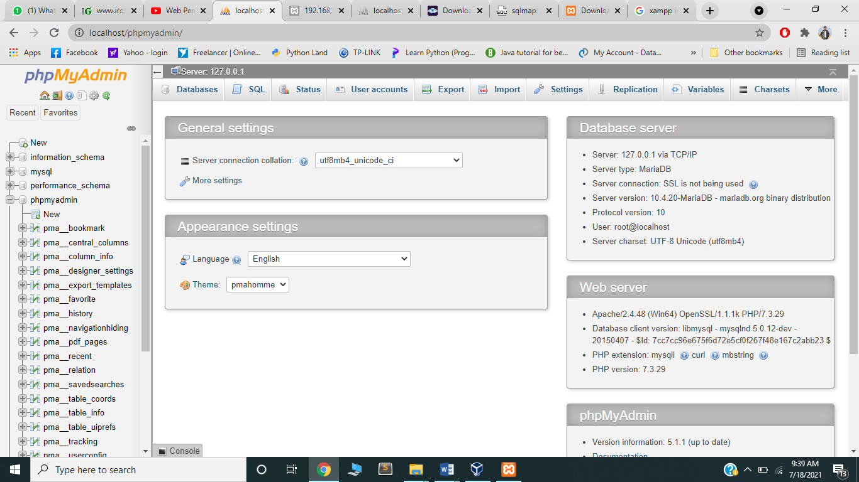

## Mutillidae application setup

* Visited the following link to download the Mutillidae application setup from [www.irongeek.com](http://www.irongeek.com) website to download the ZIP folder.

<http://www.irongeek.com/i.php?page=mutillidae/mutillidae-deliberately-vulnerable-php-owasp-top-10%20>

* Unzip the downloaded zip folder.
* Placed the unzipped folder of Mutillidae in XAMPP Server folder. Detail mentioned below:-

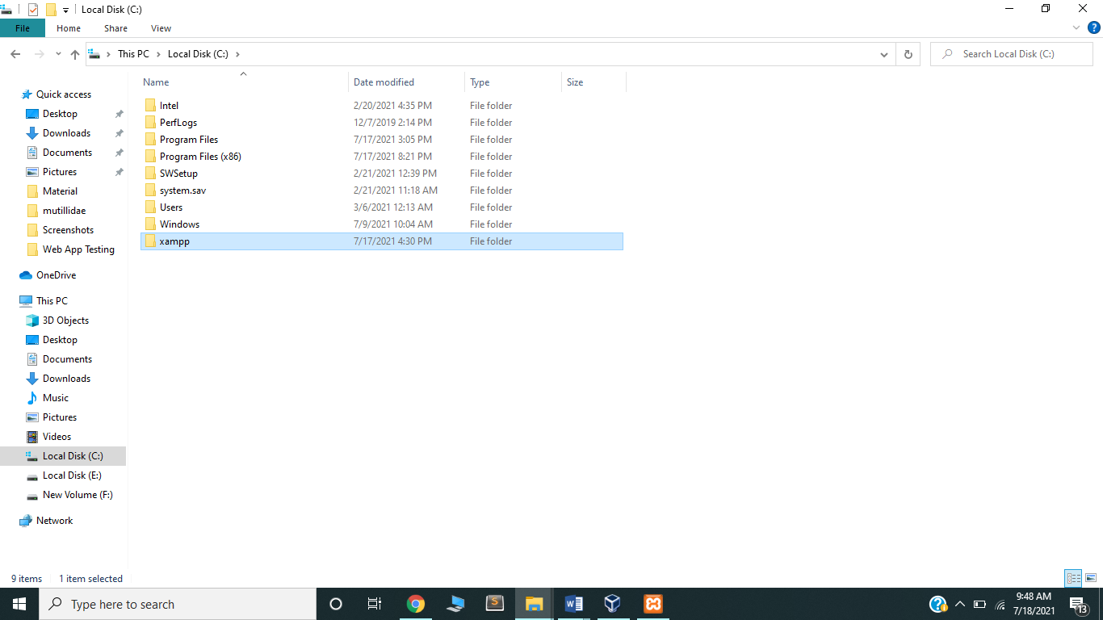

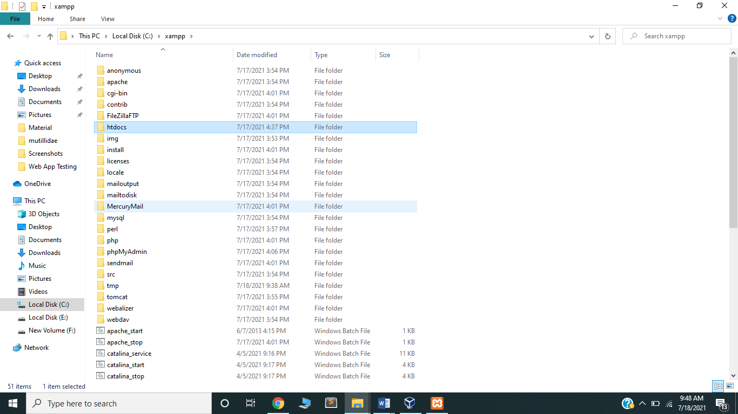

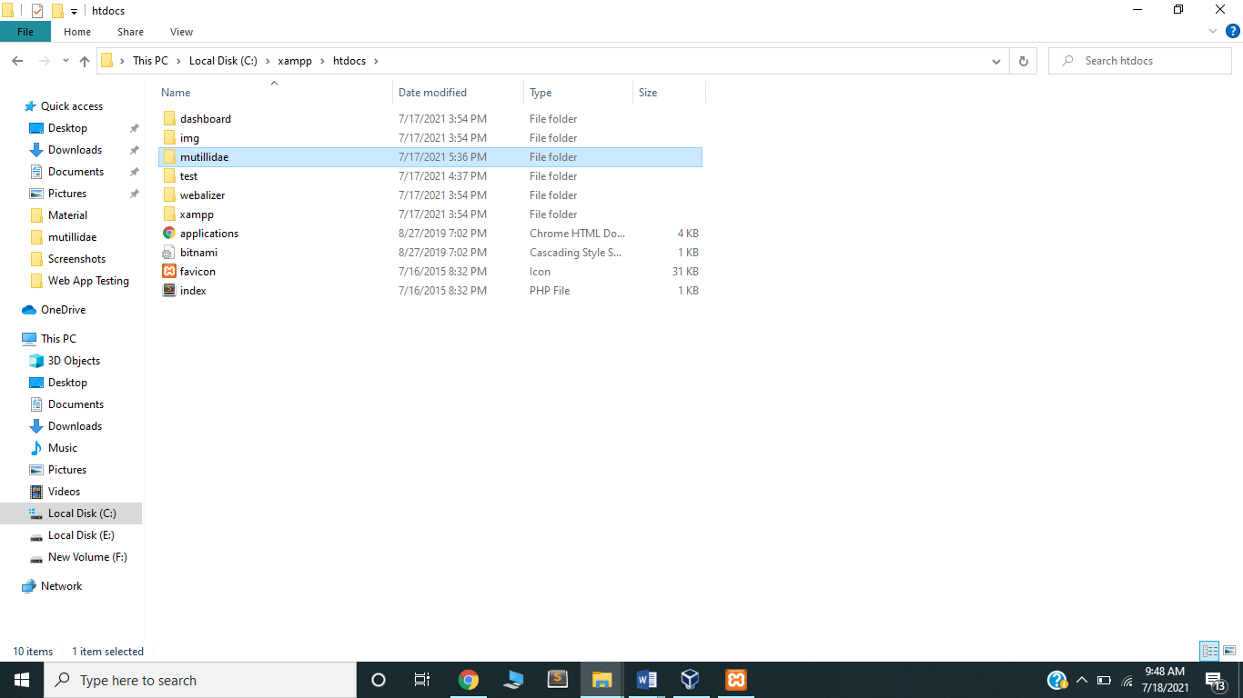

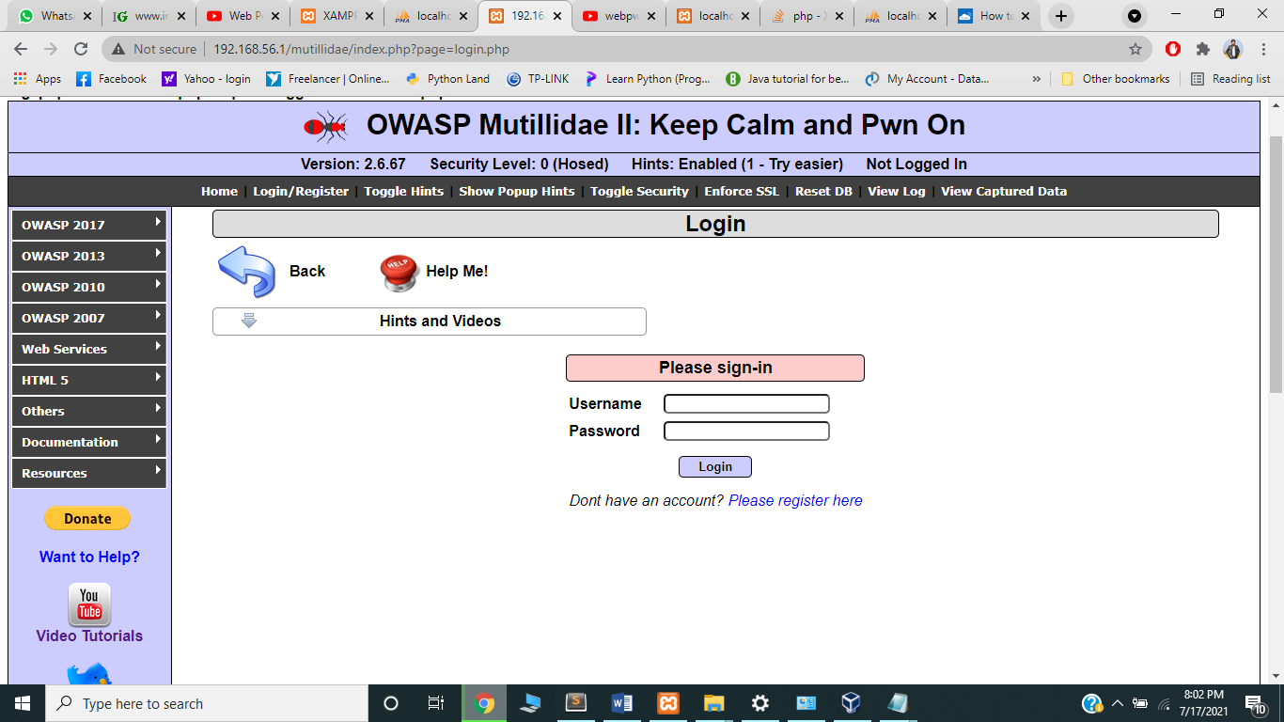

# **Web Application Security Testing Setup**

## NMAP scanning setup/ configuration

* Visit [www.nmap.org](http://www.nmap.org) website.
* Clicked on download tab.
* Scrolled down and selected Microsoft Windows version from Other Operating System section. Detail as per diagram:-

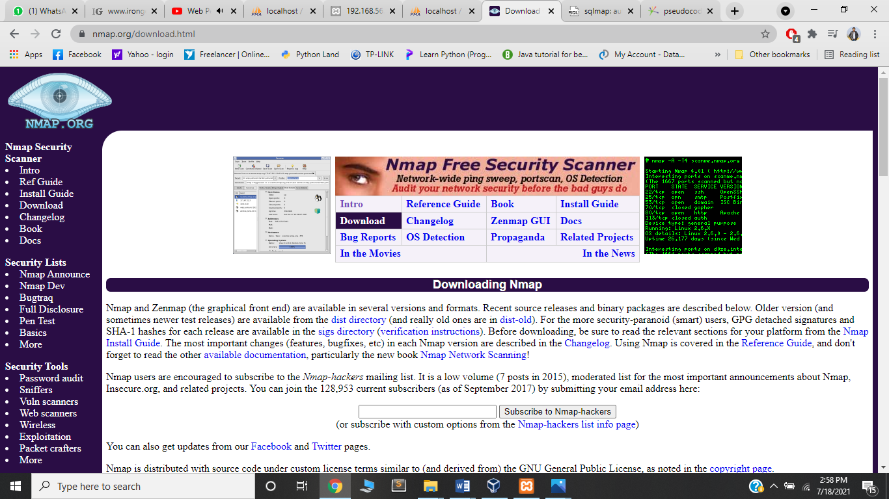

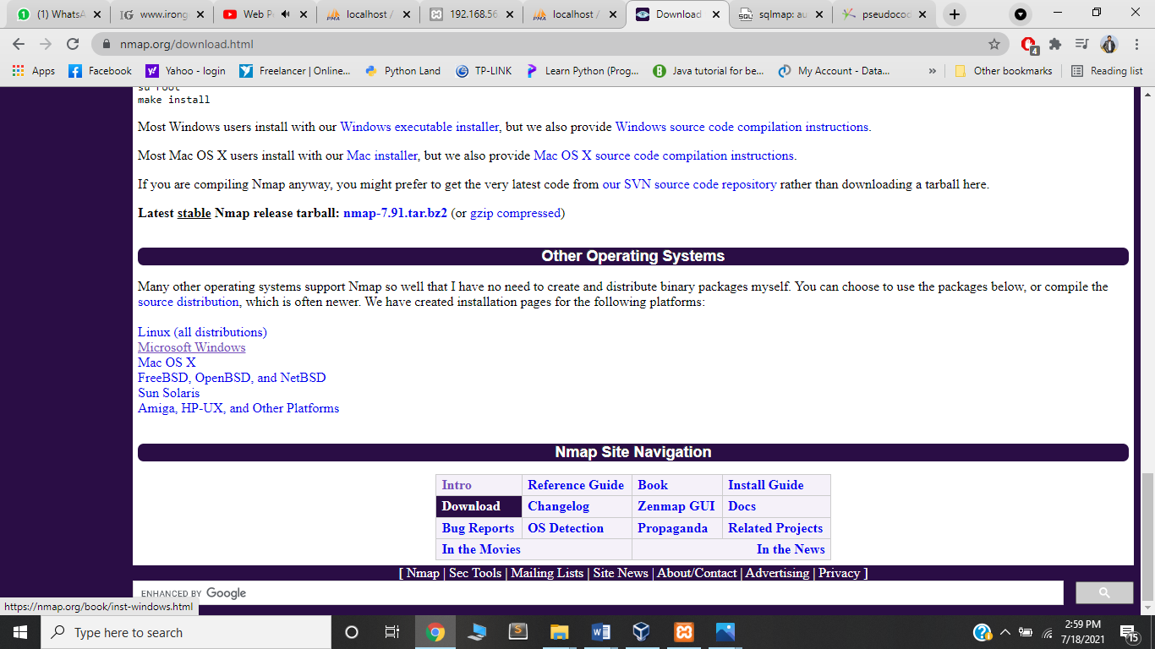

* For installation followed steps as mentioned below:-

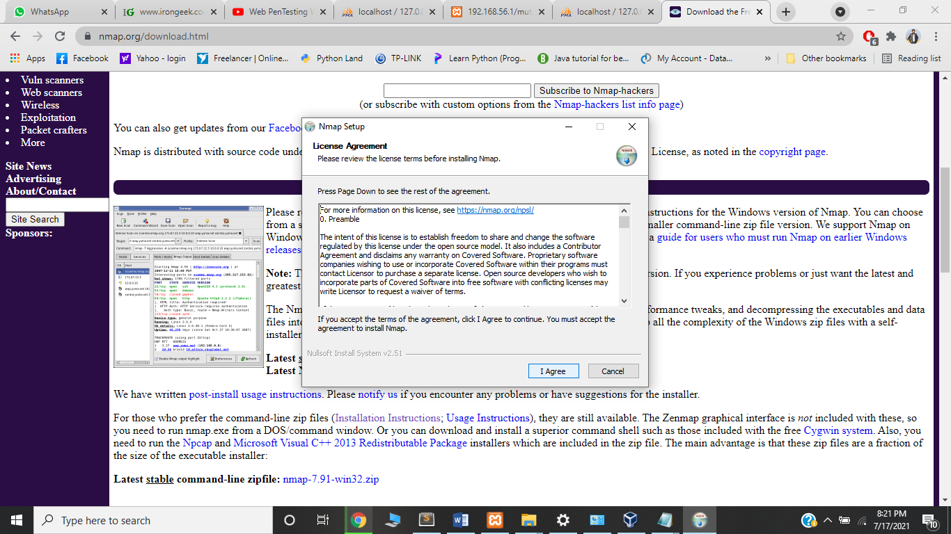

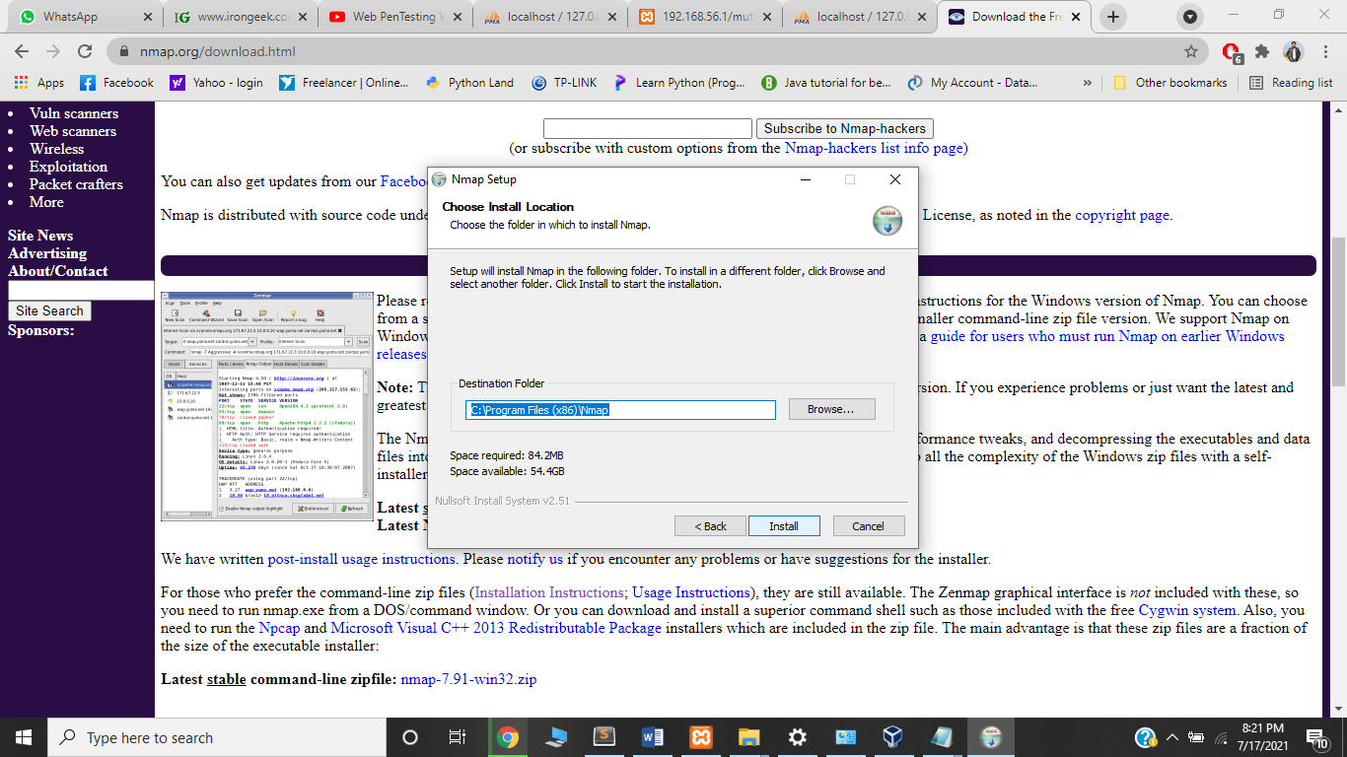

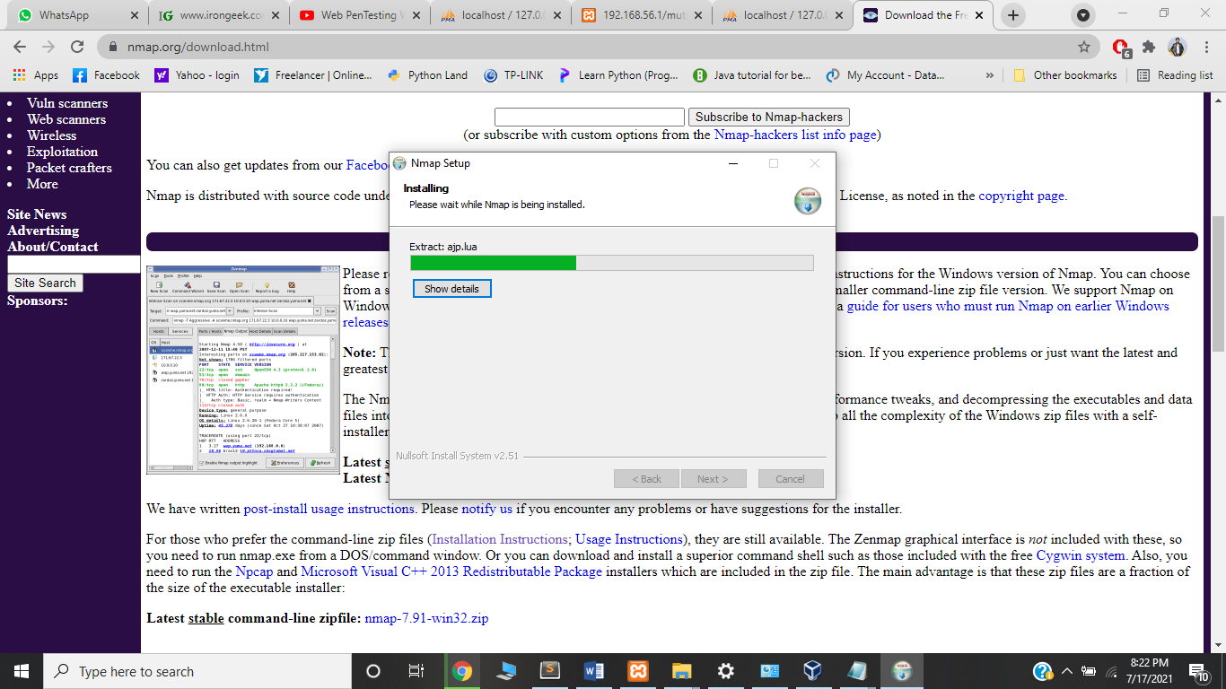

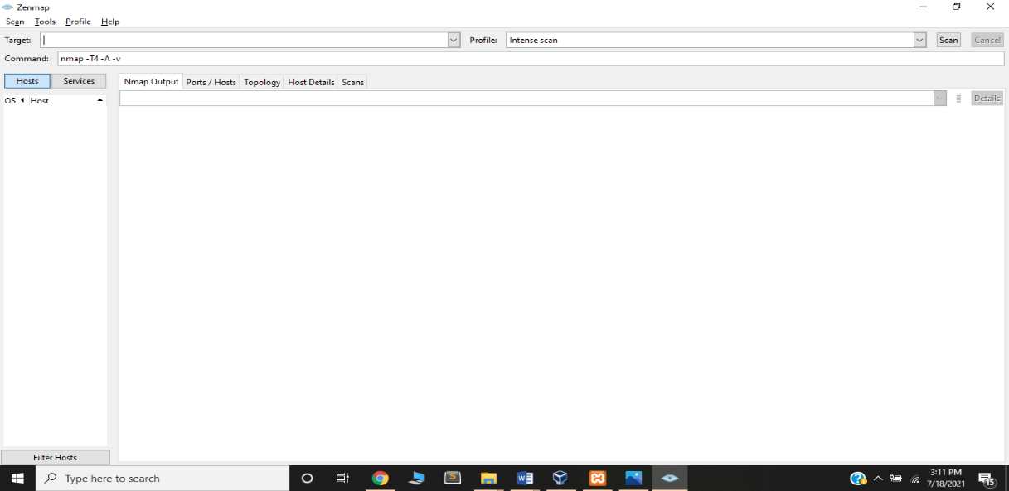

**(NMAP Application)**

* Scanning result for [www.nmap.org](http://www.nmap.org) mentioned below:-

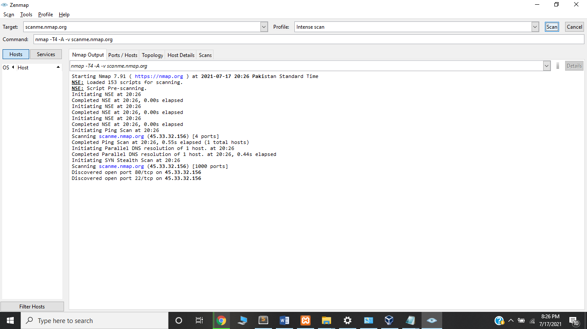

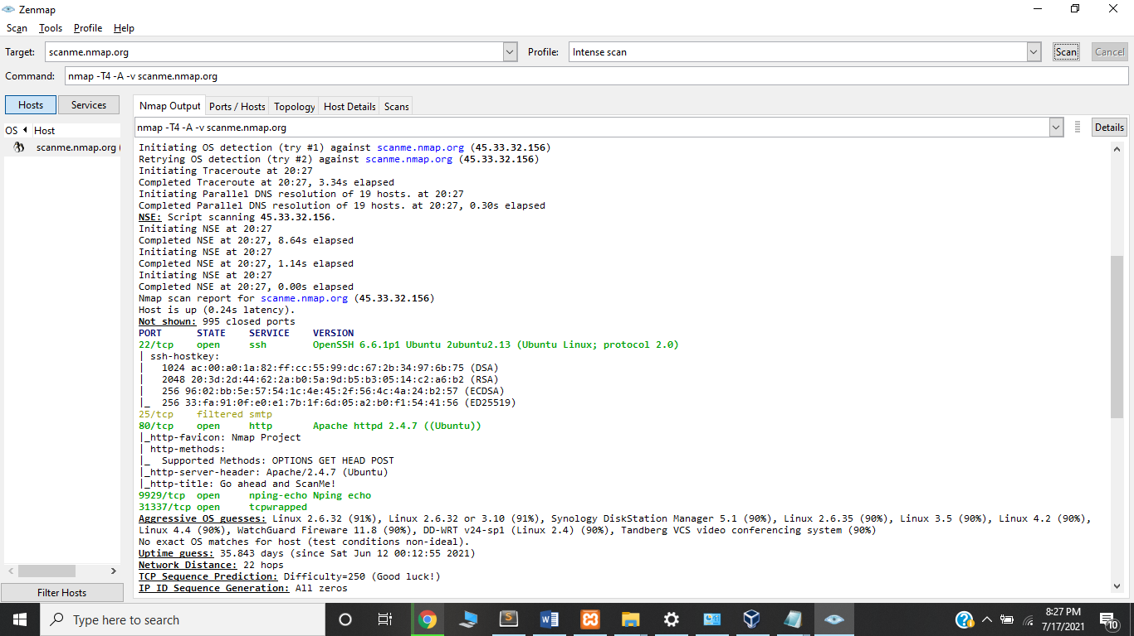

* nmap -v -sn 192.168.0.0/16 10.0.0.0/8, show the range of IP addresses:-

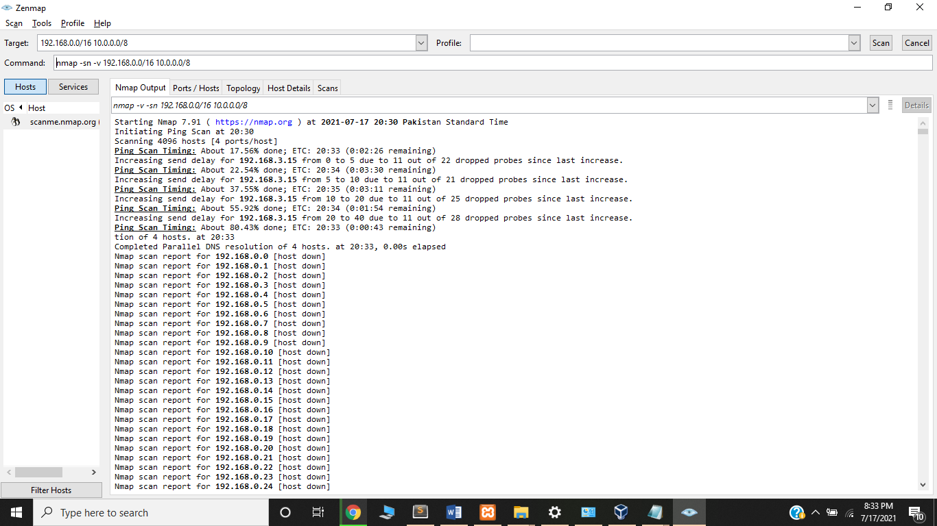

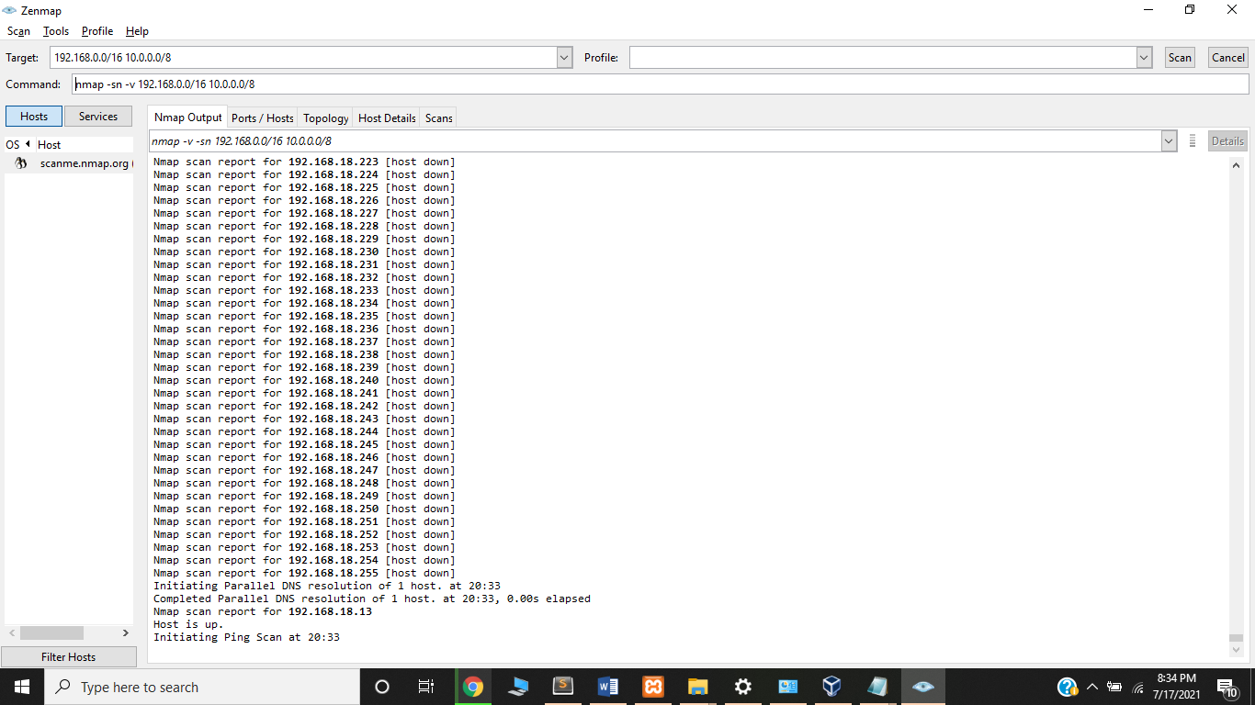

* Scanning result for local network of PC:-

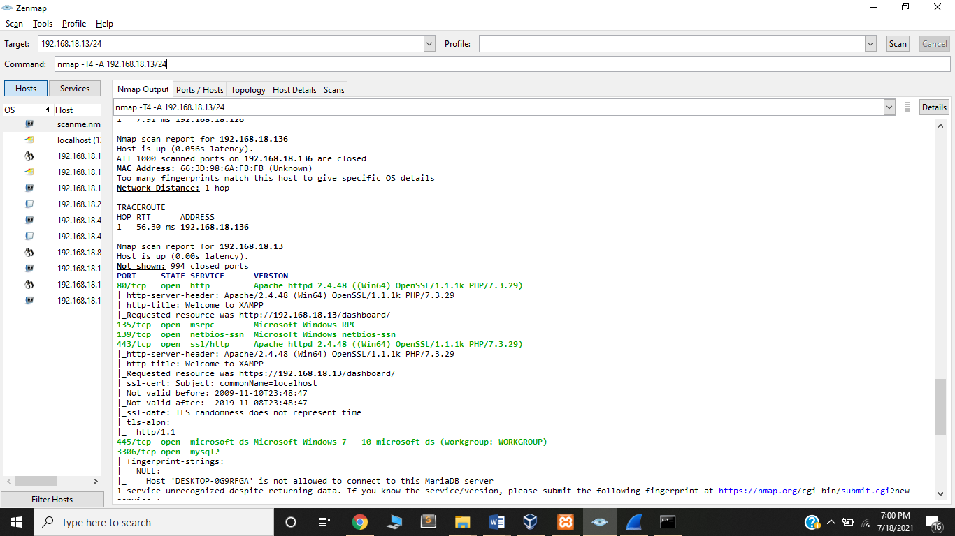

* Scanning Open Ports using *nmap -A -T4 localhost* mentioned below:-

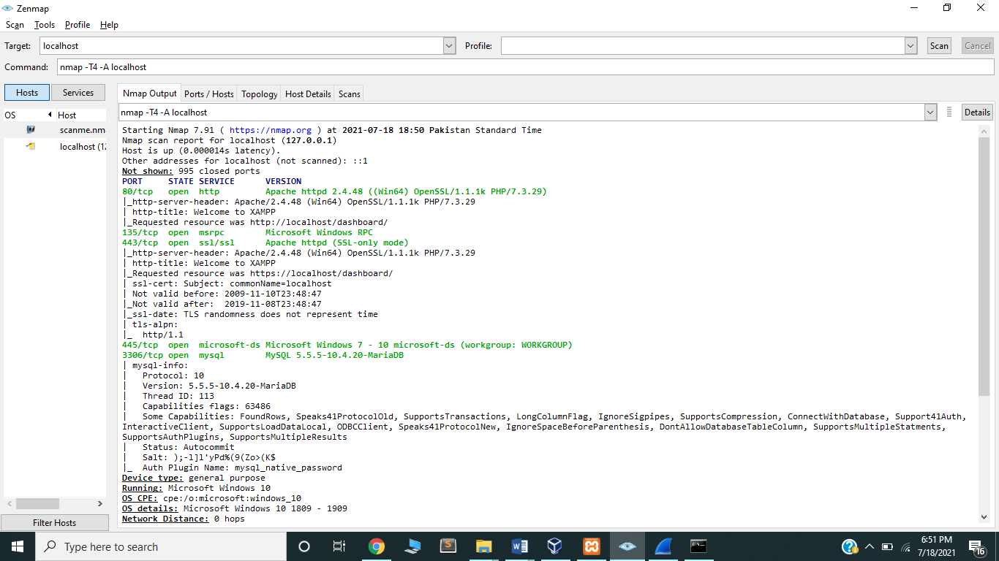

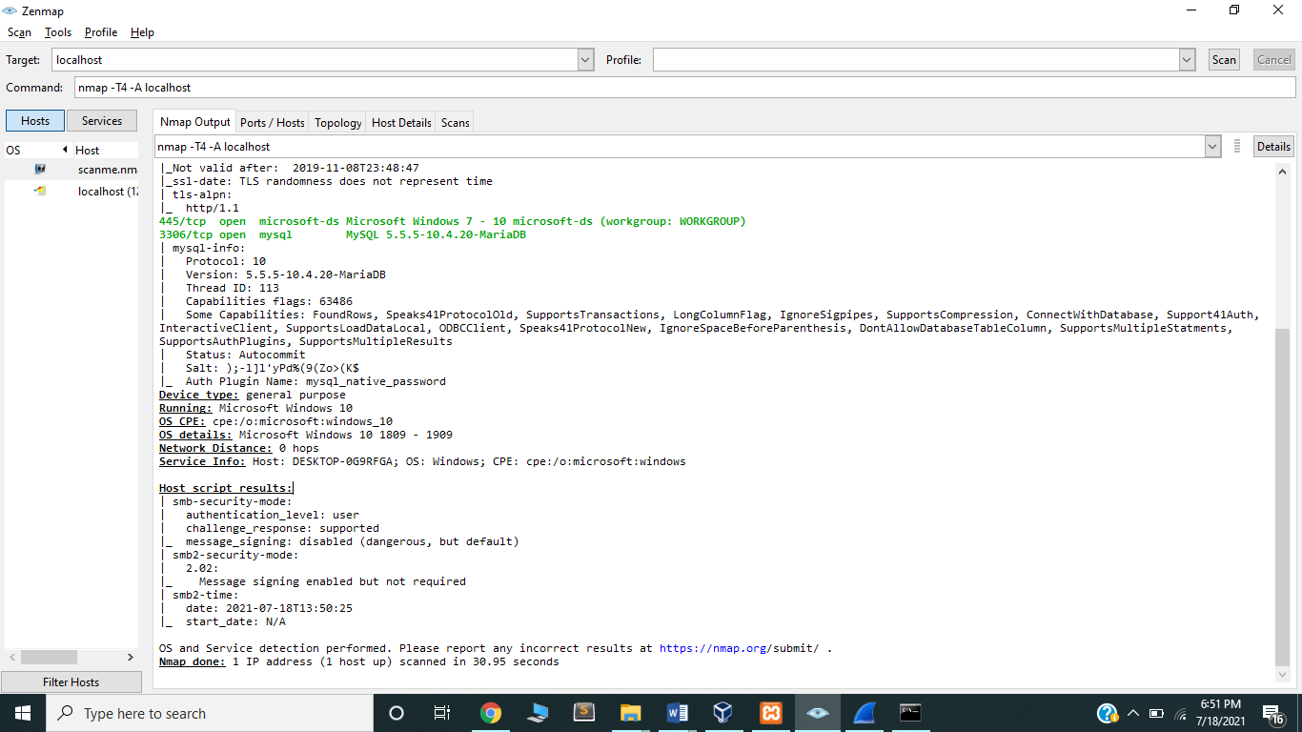

## Wireshark sniffing setup/ configuration

* Visit [www.wireshark.org](http://www.wireshark.org) website.
* Clicked download tab.
* Selected windows installer (64 bit) for setup. Details mentioned below:-

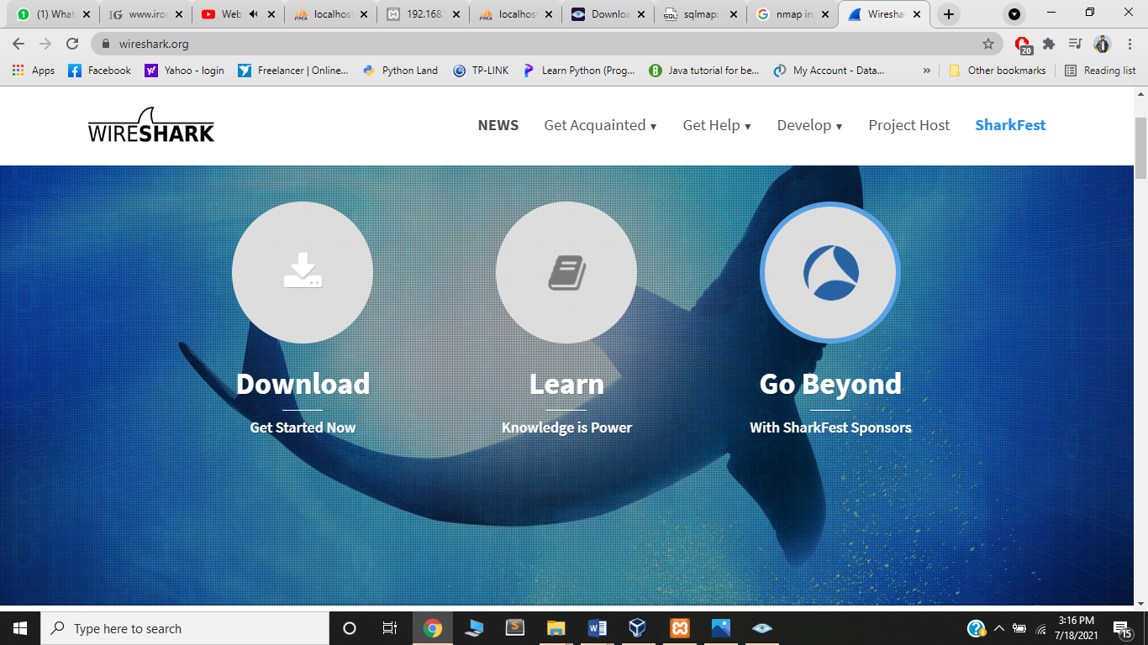

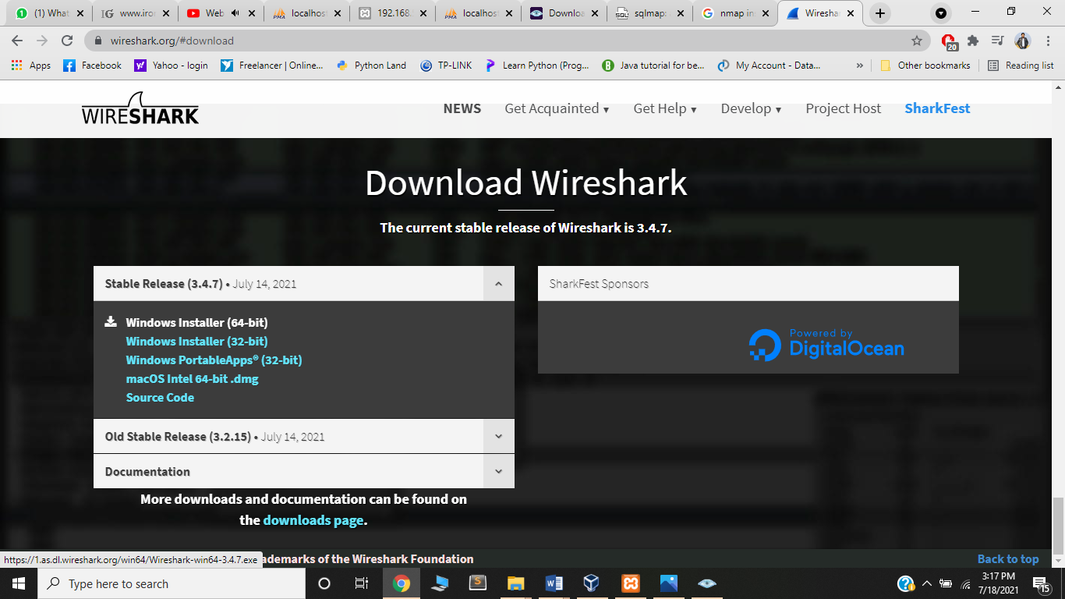

* After downloading, following steps followed for installation:-

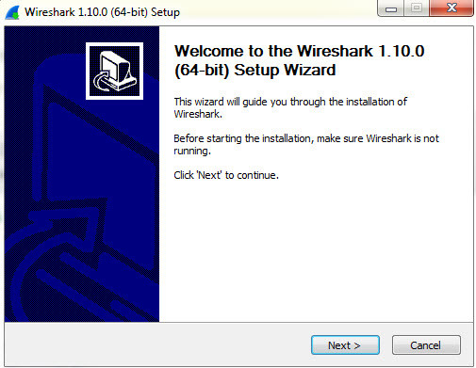

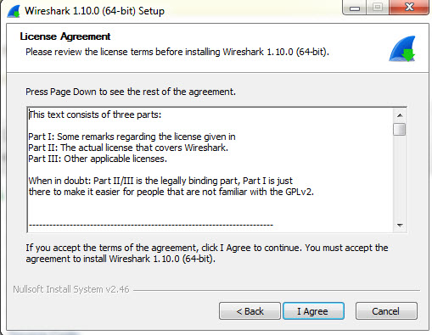

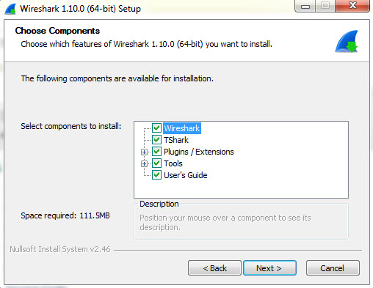

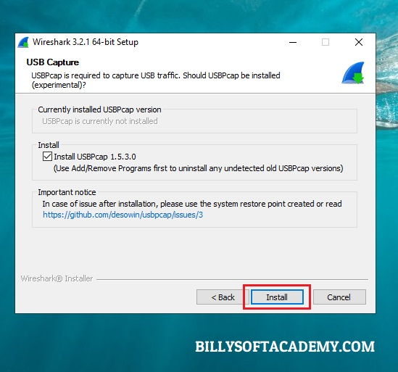

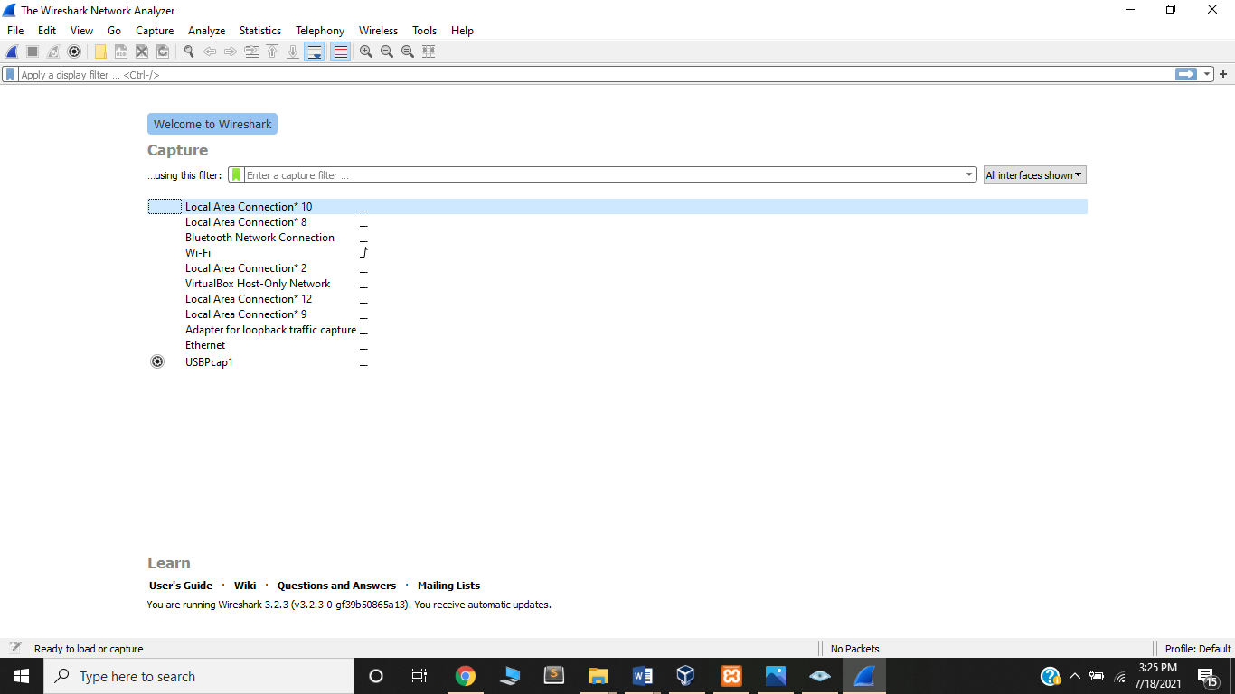

**(Wireshark Application Display)**

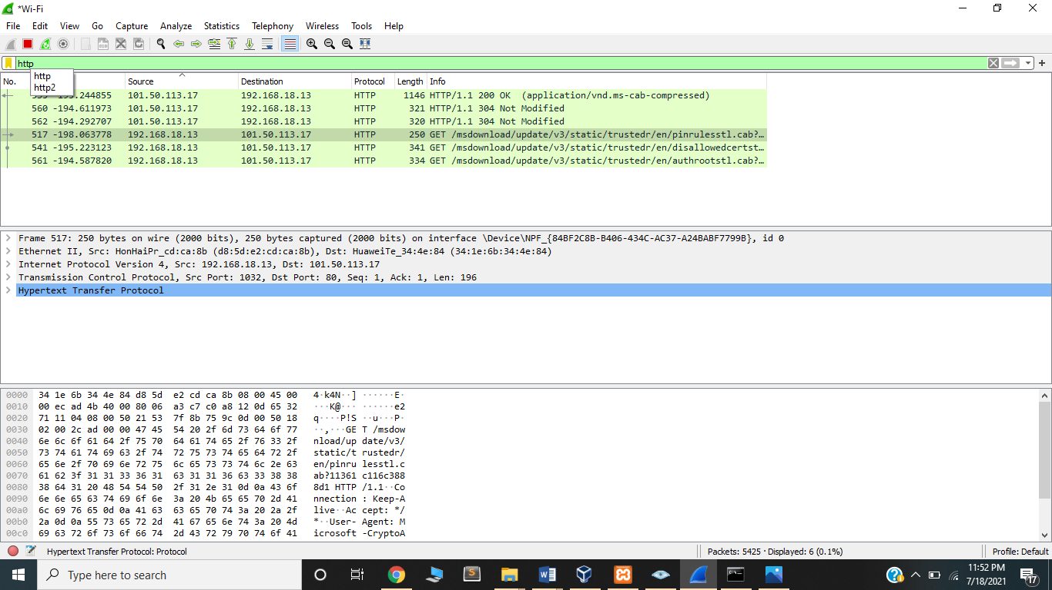

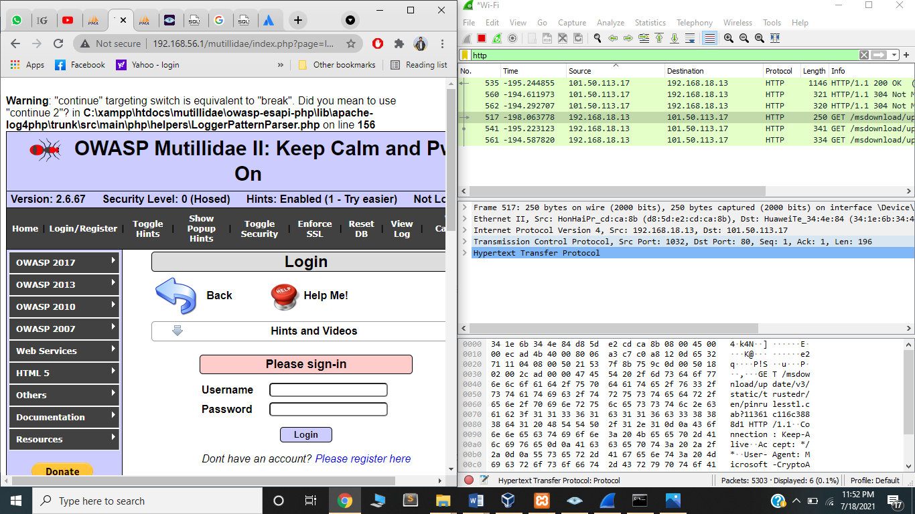

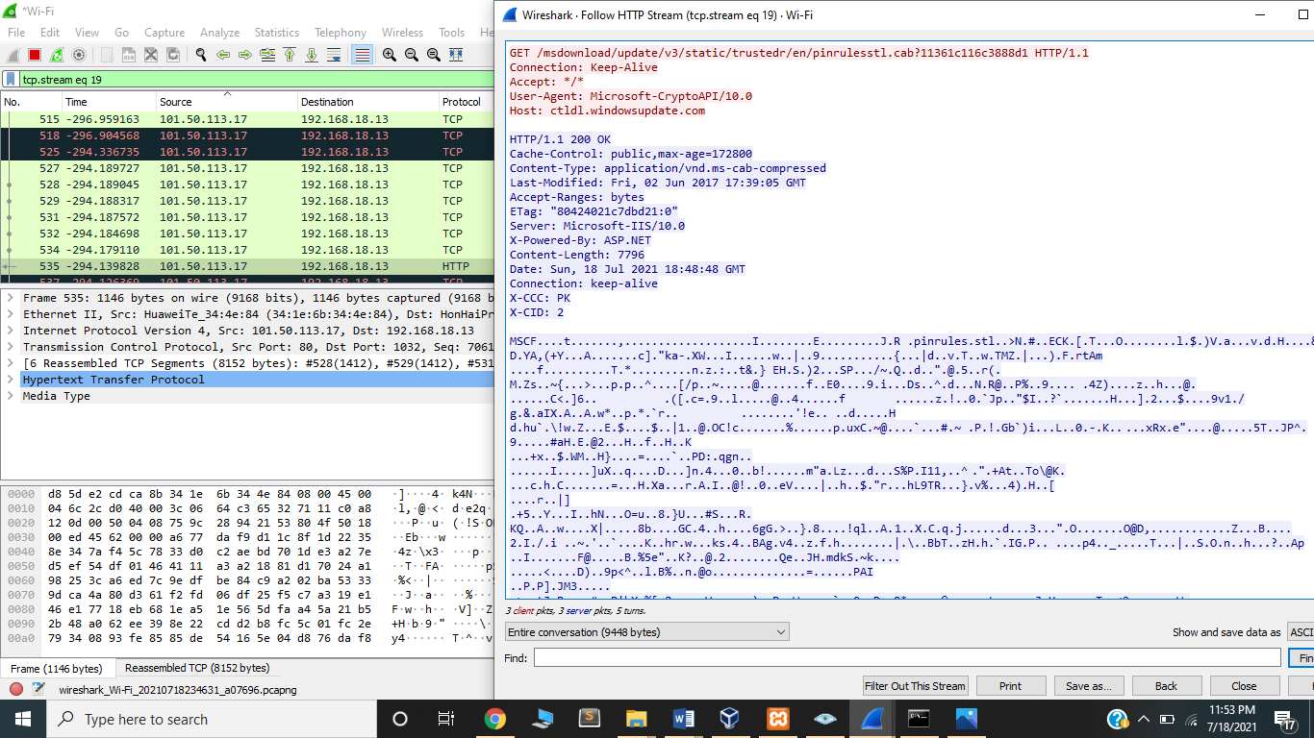

## SQL injection using SQLMAP setup/ configuration

* Visit [www.sqlmap.org](http://www.sqlmap.org) website.
* Clicked on Download.zip file from left side of main menu of site.
* After downloading, unzipped the folder.
* Clicked sqlmap application for installation steps followed mentioned below:-

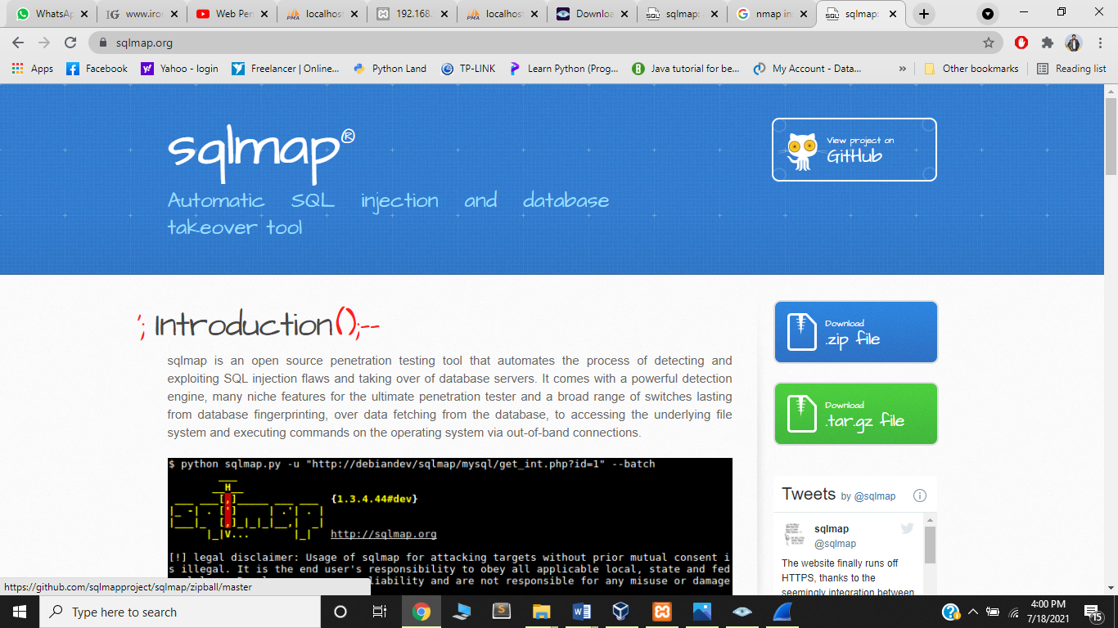

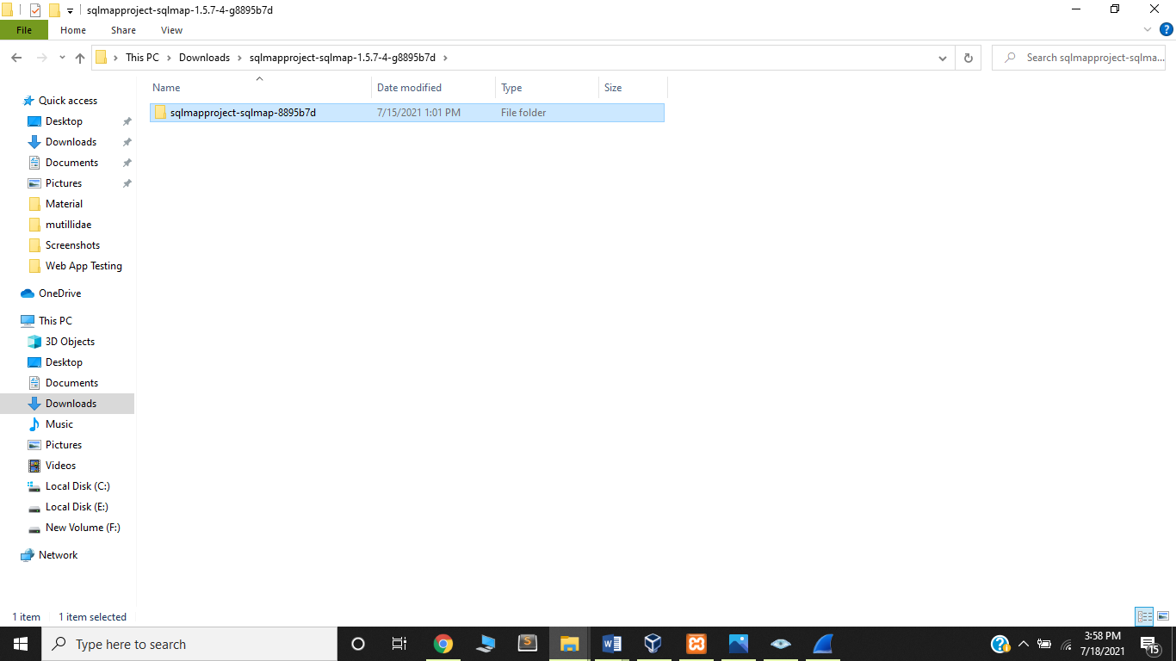

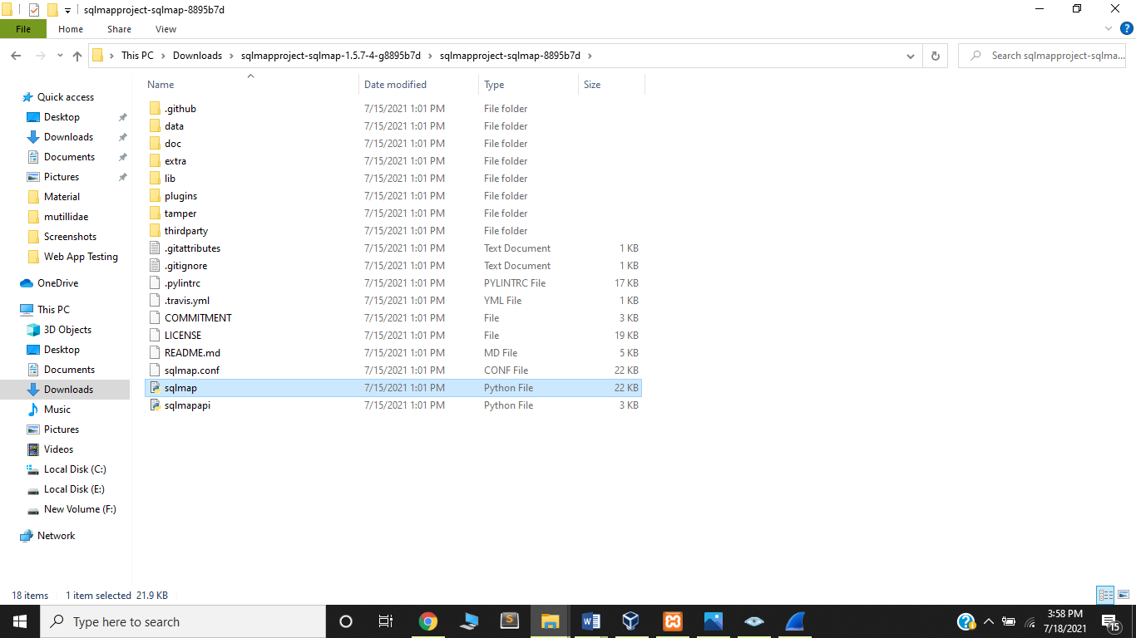

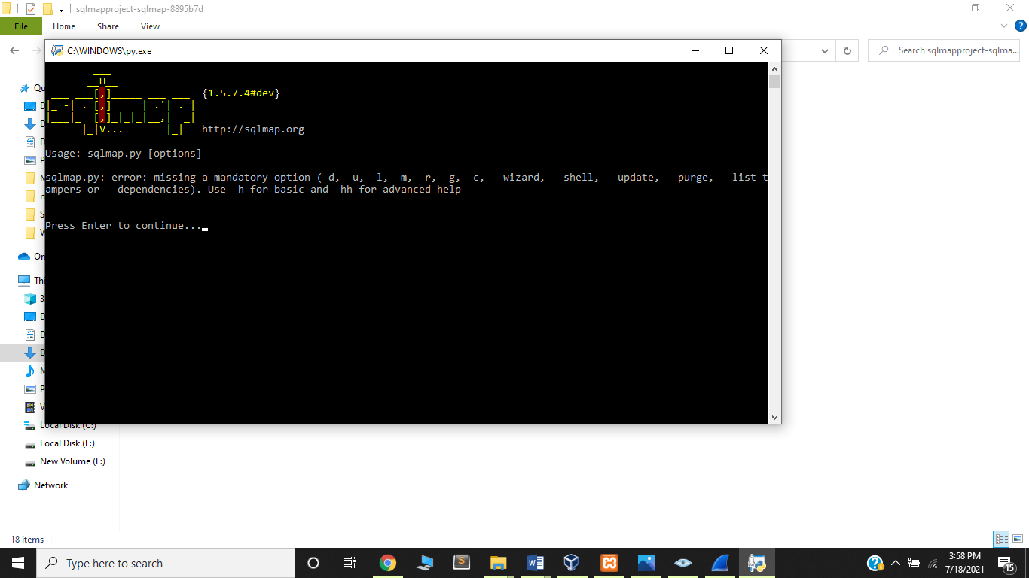

* Scanning result of mutillidae application is as under:-

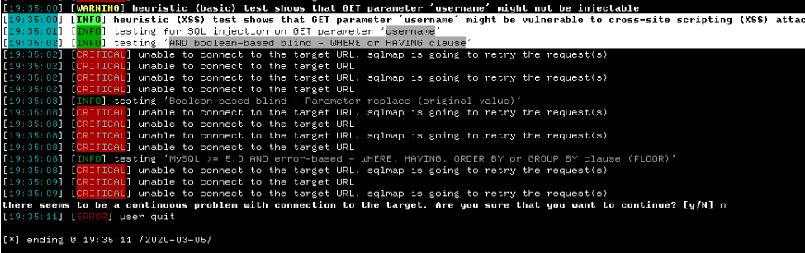

* Scanning result of database is as under:-

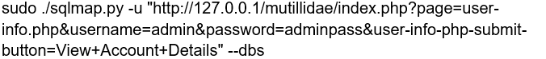

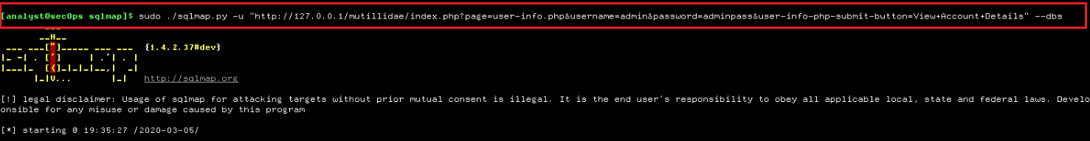

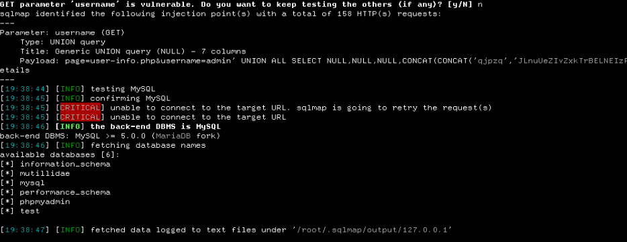

# **Design and Implementing a Web Security Model**

## Firewall

Firewall is security device based on software/ hardware or both to protect the system/ application from unauthorized access. Firewall in network security known as to protect the network from unauthorized traffic, monitor incoming/ outgoing network traffic and decides whether to allow or deny the traffic from firewalls. Firewall considered as the first security check of any application in cyber security to protect the system or network. Firewall works based on set of rules in form of IPs to apply on firewall for network to allow or deny specific IPs for traffic using access control list (ACL). Basic network diagram using firewall is as:-

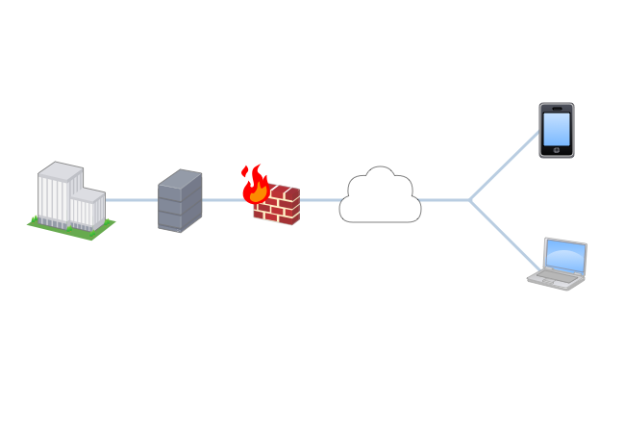

**(Basic Network Diagram using Firewall)**

## IDS/ IPS

Intrusion detection system (IDS) is a device or software application that monitors a network/ application for malicious activities or policy/ rules violations. All unauthorized activities either directly reported to administrator or collected centrally using security information and event control management system.

Intrusion prevention system (IPS) is device/ software to detect and prevent identified threats. IPS also directly reports the threats to administrator of the system and takes preventives measures by closing access points and configuring the firewalls to prevent system from future attacks.

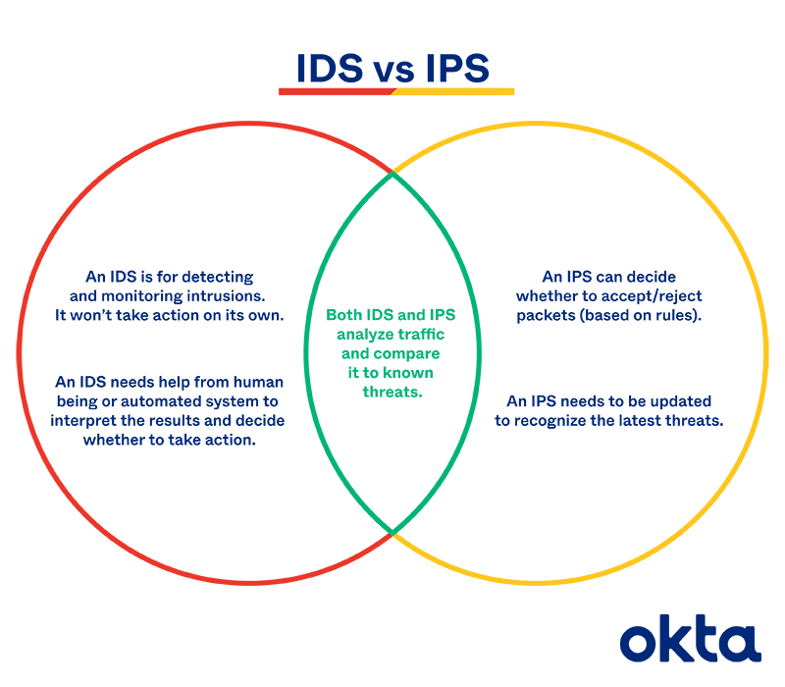

## Antivirus

Antivirus is software also known as anti-malware which is basically computer program used to detect, prevent, remove malware from system/ software and secure system from viruses. Antivirus continuously remains open checks the system from threats/ viruses. Antivirus also monitor real time threats, protects ad restricts the spread of viruses. It also helps for protecting the public and private network from vulnerabilities by scanning device files and looking potential risk regularly.

## Encryption

Encryption is basically known as encoding/ decoding of confidential information of any type for system/ application. Encryption also means not obvious/ unclear so it helps the business to secure the data of customer/ business so neither can access the information nor manipulate the data. Encryption performed by generating different keys for decoding the encrypted data to read because encrypted data is not human readable. The information transmitted over network if encrypted the key must be shared to end device so recipient must have key to decode the information. Following are the encryption types:-

* Symmetric Encryption. There is only one key for all communicating parties use same secret key for encoding and decoding.
* Asymmetric Encryption. There is two keys used for encoding/ decoding. The key for encoding can be shared publically but the key for decoding must be shared secretly. This type of encryption is TLS often called SSL.

def caesar_encrypt():

word = input('Enter the plain text: ')

c = ''

for i in word:

if (i == ' '):

c += ' '

else:

c += (chr(ord(i) + 3))

return c

def caesar_decrypt():

word = input('Enter the cipher text: ')

c = ''

for i in word:

if (i == ' '):

c += ' '

else:

c += (chr(ord(i) - 3))

return c

plain = 'hello'

cipher = caesar_encrypt(plain)

decipher = caesar_decrypt(cipher)

**(Basic Code of Encryption/ Decryption)**

# **References**

Bryan Sullivan, V. L. (2011). *Web Application Security, A Beginner's Guide.* McGraw Hill Professional.

Joel Scambray, V. L. (2010). *Hacking Exposed Web Applications, Third Edition.* McGraw Hill Professional.

Splaine, S. (2002). *Testing Web Security: Assessing the Security of Web Sites and Applications.* Wiley.

Vittie, L. M. (2015). *Web Application Security is a Stack: How to CYA.* IT Governance Ltd.

Zalewski, M. (2011). *The Tangled Web: A Guide to Securing Modern Web Applications.* No Starch Press.